**Que 1. What is software? What is software engineering?**

**Ans**. Software is more than a program code, Program is an executable code, which servers some computational purpose. Software is also considered to be executable programming code, libraries and documentations.

Software, when made for a specific requirement is called Software.

**Software Engineering :**

Software Engineering is a process of designing, developing, testing and maintaining software. It is a systematic and disciplined approached to software development that Amis to create high quality,

Reliable and maintainable software.

**Que2. Explain types of software**

**Ans 2. Types of software:**

* Application Software
* System software
* Driver software
* Middleware
* Programming software

Application software:

* An application can be self contained, or it can be a group of programs that run the application for the user.
* Most common types of software, application software is a computer software package that performs a specific function for a user, or in some cases for another application.
* Examples are graphics software ,database and database management programs, image editors and communication.

System Software :

* These software programs are designed to run a computer’s application programs and hardware.
* System co ordinates the activities and function of hardware and software.
* Examples are Firmware, computer language translators and system utilities.

Driver software:

* Also known as device drivers , This software is often considered a type of system software
* Device drivers control the devices and peripherals connected to a computer, enabling them to perform their specific task.
* Every devices that are connected to a computer needs at least one device driver function
* Examples Special game controllers , as well as the software that enable standard hardware system, such as Headphones, printers, keyboards and printers.

Middleware:

* The term middle ware describe software that mediates between application and system software or between

Two different application software.

* Example Middleware enables Microsoft windows to talk to excel and word.

Programming software:

* Programmers use programming software to write code.
* Programming software and programming tools enable developers to develop, write, test and debug.
* Examples compilers, debuggers and interpreters, Turbo c, sublime etc.

**Que 3.What is SDLC? Explain each phase of SDLC?**

**Ans.** Software Development Life Cycle (SDLC) is a framework that defines the steps involved in the development of software at each phase. It covers the detailed plan for building, deploying and maintaining the software.

SDLC defines the complete cycle of development i.e. all the tasks involved in planning, creating, testing, and deploying a Software Product.

**Phase of SDLC**

* Requirement gathering and analysis
* Design
* Implementation or coding
* Testing
* Deployment
* Maintenance

1. **Requirement gathering and analysis :**

During this phase, all the relevant information is collected from the customer to develop a product as per their expectation. Any ambiguities must be resolved in this phase only.

Business analyst and Project Manager set up a meeting with the customer to gather all the information like what the customer wants to build, who will be the end-user, what is the purpose of the product. Before building a product a core understanding or knowledge of the product is very important.

1. **Design:**

In this phase, the requirement gathered in the SRS document is used as an input and software architecture that is used for implementing system development is derived.

1. **implementing and coding:**

Implementation/Coding starts once the developer gets the Design document. The Software design is translated into source code. All the components of the software are implemented in this phase.

4.**Testing:**

Testing starts once the coding is complete and the modules are released for testing. In this phase, the developed software is tested thoroughly and any defects found are assigned to developers to get them fixed.

Retesting, regression testing is done until the point at which the software is as per the customer’s expectation. Testers refer SRS document to make sure that the software is as per the customer’s standard.

* 1. **Deployment:**

Once the product is tested, it is deployed in the production environment depending on the customer expectation.

In the case of UAT, a replica of the production environment is created and the customer along with the developers does the testing. If the customer finds the application as expected, then sign off is provided by the customer to go live.

* 1. Maintenance:

After the deployment of a product on the production environment, maintenance of the product i.e. if any issue comes up and needs to be fixed or any enhancement is to be done is taken care by the developers.

**Que.4** **What is DFD? Create a DFD diagram on Flipkart?**

**Ans.** A data flow diagram (DFD) maps out the flow of information for any process or system. It uses defined symbols like rectangles, circles and arrows, plus short text labels, to show data inputs, outputs, storage points and the routes between each destination. Data flowcharts can range from simple, even hand-drawn process overviews, to in-depth, multi-level DFDs that dig progressively deeper to how the data is handled to how the data is handled 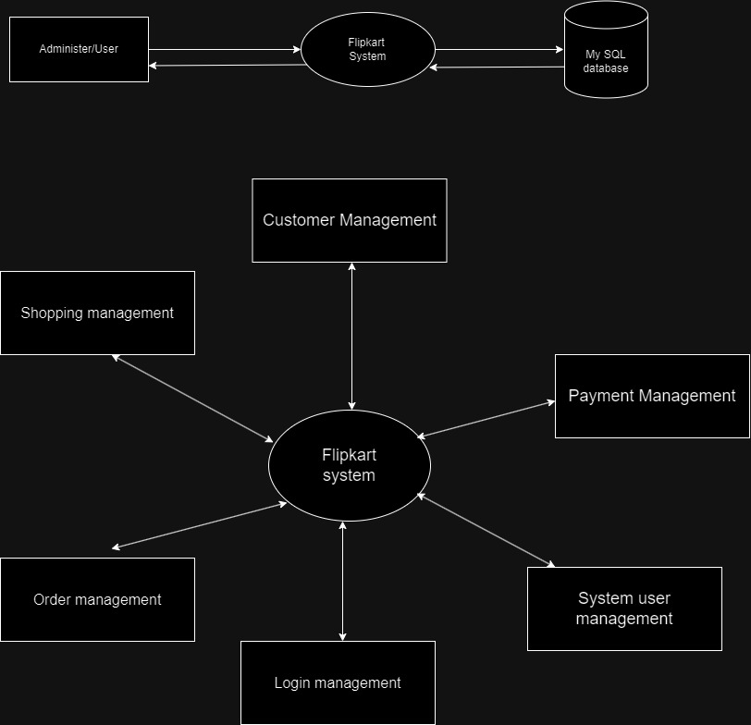

**Que 5. What is Flow chart? Create a flowchart to make addition of two numbers?**

**Ans.** A flowchart is a type of diagram that represent workflow or process. Flowchart can be defined as a grammatic Representation of an algorithm, step by step approach to solving a tasks.

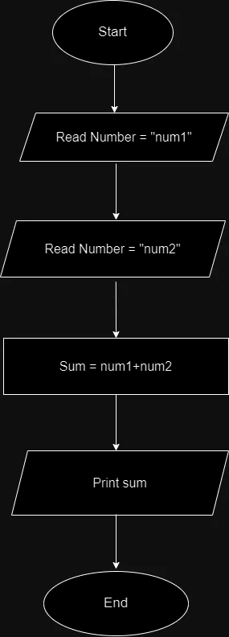

**Que 6.** **What is Use case Diagram? Create a use-case on bill payment on paytm?**

**Ans:** A use case diagram is a graphical depiction of a user's possible interactions with a system. A use case diagram shows various use cases and different types of users the system has and will often be accompanied by other types of diagrams as well. The use cases are represented by either circles or ellipses. The actors are often shown as stick figures.

